Call for Emerging Artist Exhibition Proposals for Level 2 Project Space 2020

The Koorie Heritage Trust invites Aboriginal and Torres Strait Islander emerging artists/art collectives living in Victoria to participate in our 2020 Exhibition Program in our Level Two Project Space. In 2020, we are offering three exhibition slots from March – November. Applicants who were unsuccessful in the 2019 call out are encouraged to re-apply.

The Project Space operates to showcase emerging artists working in a variety of media and disciplines. Emerging generally refers to artists in the first five years of their professional arts practice (not including art studies).

Those interested in exhibiting in this space will need to propose a theme or concept for the exhibition. This could be a solo exhibition of new or existing works, a group show exploring a specific topic, an installation etc.

If this sounds like you, we encourage you to read through the attached information and submit an application! If you would like to discuss your idea, or ask any questions, feel free to contact Assistant Curator Moorina Bonini on mbonini@koorieheritagetrust.com or on 03 9662 6336.

Please note - there is no public lift access to the Level 2 Project Space. Goods lift access can be provided for the installation period and for opening events. Otherwise, access is via a set of escalators (going up only) or 23 stairs with a 1300mm landing and a handrail on both sides. If you have any access inquiries, contact us to discuss further.

**Applications close Friday 6 December 2019**

IMPORTANT INFORMATION

1. Key dates

Applications open: Friday 13 September 2019.
Applications close: Friday 6 December 2019.
Please note: Applications received after this time will not be considered. The selection panel will determine the dates and lengths of exhibitions, but a minimum exhibition period of 8-weeks per project will be allocated. Applicants will be notified of the results by Friday 24 January.
Exhibitions will commence in March 2020.

2. Selection Criteria
- Applicants must be Aboriginal and/or Torres Strait Islander, currently living in Victoria. Indigenous applicants wishing to collaborate with non-Indigenous artists, must speak with the Curatorial Team before submitting an application.
- Applicants must be at an emerging level in their career.
- Proposals must describe a body of work or exhibition theme/concept with ideas of proposed artists and/or artworks listed.

3. Selection Panel
The Koorie Heritage Trust Curatorial Team and the CEO will assess exhibition proposals and make selections. Selection Criteria:
- Is the project achievable, in terms of the timeframe, budget and resources required.
- Is the project suitable for the space?
- Is the project creative, innovative and thought provoking in its subject matter, execution and techniques?
The Assistant Curator will notify all applicants of the outcome in January 2020, and will provide feedback if requested. The outcome of the EOI assessment is final and no correspondence will be entered into.

4. Payment To Artists
KHT will make a single payment amount of $1,000 to the artist for each successful application. KHT will also make a one off payment of $500 to cover the cost of materials. This payment is intended to cover all costs incurred by the applicant including transportation costs and materials, details of which can be found in the Terms and Conditions, specifically Section 2. If you are considering applying as a collective with multiple artists, please call the Assistant Curator to discuss the artist payment.

5. How To Submit
Applicants must:
- Complete the attached Application Form, including a description of the proposed exhibition, name(s) of artist(s) involved and any technical or display requirements.
- Attach (either in email or printed out and posted) a current bio and CV (max 2 A4 pages) for each participating artist.
- Provide photos or videos of examples of relevant artworks as attachments or links.

6. Exhibition design
KHT encourages applicants to think creatively about exhibition design and the display of works. The space on offer is an unconventional gallery space and we encourage applicants to respond appropriately and innovatively. We have a number of exhibition plinths, TV screens, and other exhibition furniture, that may be available for use in the exhibition. The use of existing exhibition furniture and equipment, along with any additional requirements will form part of the exhibition design development with the exhibition staff. Please note, lighting on Level Two is fixed and light levels are unable to be adjusted. See floor plan for exhibition space attached.

Please email completed application forms with attachments to Moorina Bonini, Assistant Curator by email at mbonini@koorieheritagetrust.com or hard copy: ATTN Moorina Bonini, Koorie Heritage Trust, Levels 1 & 3, The Yarra Building, Cnr Flinders & Swanston Streets, Federation Square, Melbourne VIC 3000.

If you have any questions about the application, or wish to discuss your ideas, please call Moorina on (03) 8662 6336 or email ahead of the application due date. Moorina is available and happy to help discuss project ideas, installation plans and any assistance you may need filling out your application.

APPLICATION FORM

Details of Applicant:
NAME
LANGUAGE GROUP
DATE OF BIRTH
GENDER | ☐ Prefer not to say
DO YOU IDENTIFY AS*: | ☐  ☐ Disability community member  ☐ LGBTQIA+  ☐ Culturally and Linguistically Diverse (in addition to Aboriginal and/or Torres Strait Islander community member)
ADDRESS
EMAIL
TELEPHONE
ABN (if applicable)
*We record this information for reporting purposes and to ensure our program is diverse in it’s representation. This information will not be shared with the public.

Exhibition Title:

Please select the box below which is most relevant to you

☐ Artist ☐ Collective/Group

Exhibition Description:
What is the exhibition concept? (maximum 250 words)
What themes does the exhibition explore? What are the ideas behind the artworks? What mediums (e.g. paintings, videos, installation) will be used to make the exhibition?

Please describe any technical or display requirements, including audio-visual equipment. (maximum 100 words)
Does the work require any special hanging system (e.g. suspended from ceiling, plinths), media requirements (tv screens, projector, headphones).

ENQUIRIES

For any questions, assistance or for more information, please contact:

Moorina Bonini, Assistant Curator
T 03 8662 3663 | | E mbonini@koorieheritagetrust.com

SUBMISSION CHECKLIST

Attachment | Yes/No
Completed Application Form
Current Bio + CV for each participating artist.
Max 2 A4 pages per artist.
Images attached/website links provided

TERMS AND CONDITIONS

1. For each accepted exhibition the Koorie Heritage Trust is responsible for:

- Professional assistance from curatorial staff in the development and coordination of the exhibition (including providing timelines and checklists).
- Staffing of the gallery during opening hours.
- Marketing the exhibition through our website, Fed Square and City of Melbourne listings, social media, and email list.
- Management and delivery of exhibition opening including catering, non-alcoholic drinks (unless approved by CEO), and PA system. Please note: exhibition openings may be combined with exhibitions being launched in other galleries at the Koorie Heritage Trust.
- Design of electronic invitation sent to our email. This may be combined with other exhibitions being opened at the same time.
- Development and distribution of media releases sent to our media list and coordination of resulting publicity opportunities.
- Vinyl lettering signage for each exhibition.
- Assistance with exhibition curation, design and installation, including installation technicians.
- Providing access to gallery tools and any existing and available exhibition furniture and audio-visual equipment.
- Processing artwork sales if works are available for sale, which includes a 30% commission paid to the KHT.
- Creation of an in-house printed room sheet.

2. The accepted applicant is responsible for:

- Delivering the proposed exhibition in the timeframe and gallery space allocated.
- Providing a selection of high quality digital images* and a short written description suitable for publicity and promotional purposes. *If assistance is required to provide high quality digital images, please contact the Assistant Curator.
- Providing a short biography and artist statement for each participating artist.
- Providing information for the media release (to be developed by KHT staff in consultation with applicant).
- Assisting with the installation and de-installation of the exhibition.
- Delivery and collection of artworks and any additional exhibition materials or furniture to and from the Gallery.
- Providing a list of works including sales prices if the works are for sale.
- Approved applicants are encouraged to develop public program activities in conjunction with the KHT public programs coordinator, such as workshops or artist talks.

3. Insurance liability disclaimer

KHT will not be held responsible for any loss or damage to artworks during transportation. All artworks in the exhibition will be covered by KHT’s policy of insurance while on KHT premises within the agreed exhibition period, and prior to the agreed collection date. KHT will not extend insurance to cover artworks or any property not belonging to KHT that remains on premises after the specified collection date. Approved applicants are encouraged to take out insurance to cover loss or damage to artworks during transportation. Successful applicants are required to complete KHT and Fed Square OH&S Training.

4. Installation/De-installation

Timelines for installation and de-installation will be established by KHT staff in consultation with the successful applicant(s) and timelines must be strictly adhered to. The applicant(s) must be present and actively involved in the installation and de-installation of the exhibition.

Artworks included in the exhibition must remain in the exhibition for the full duration of the exhibition period.

KHT is unable to provide storage facilities. Artworks must be delivered and collected on agreed dates according to the timeline. Artworks, packing materials and tools must not be left on premises outside of the exhibition period or beyond the agreed collection date. Packing materials associated with transport will only be stored onsite if labelled correctly. Failure to collect artworks on or prior to the agreed collection date will incur charges to the applicant(s) to cover de-installation costs and removal of artworks.

5. Exhibition design

All successful applicants will be required to work with KHT exhibition staff to design the final layout of the exhibition. KHT reserve the right to make final decisions on the exhibition design and gallery presentation. KHT also reserves the right not to display works considered unsuitable for any reason or if the quality or quantity of work submitted is inappropriate for the exhibition space.

6. Catalogue/Room Brochure

Labels and an in-house printed room sheets will be produced for each exhibition by KHT staff. The successful applicant(s) will provide high quality images, artist statements and biographies on request or work with KHT to develop this collateral. KHT has full responsibility for the editorship of all text, reproductions and design related to the exhibition.

7. Exhibition Sales

The successful applicant(s) may choose whether they would like the works exhibited to be available for sale. If the works are for sale, KHT will handle all sales and add a 30% commission plus GST on the commission to the price provided by the artist. The combined artist price and the KHT commission (+ GST) will be the retail price.

8. Decision is Final

The decision of the assessment panel is final and no correspondence will be entered into.

GALLERY FLOOR PLAN
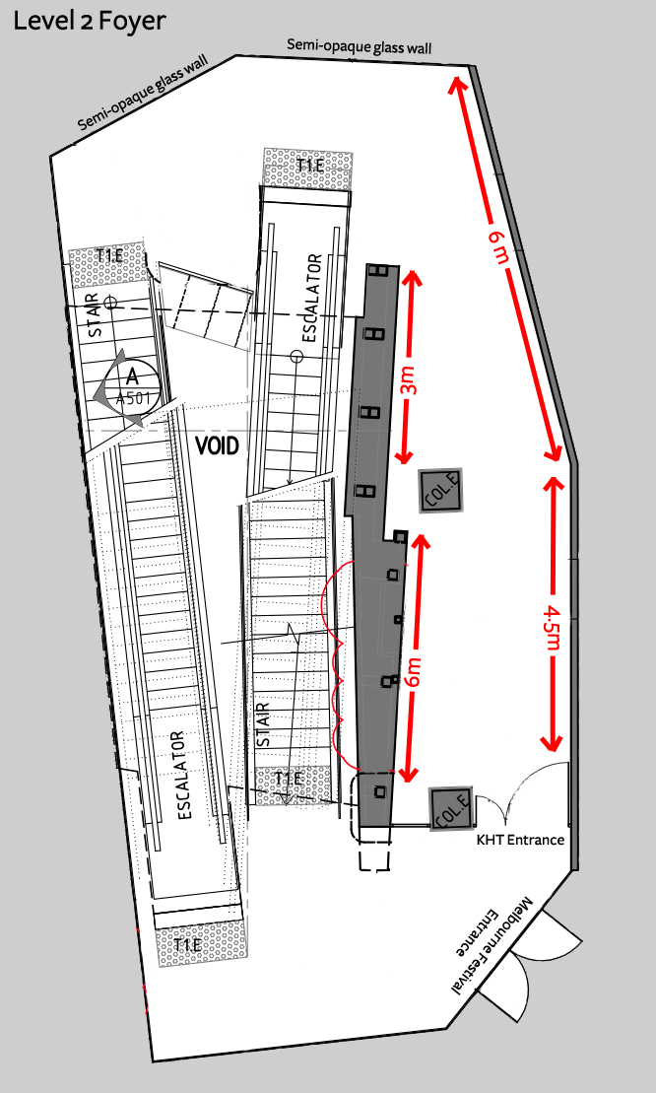
Ceiling height = 3 metres

